Project Title Maximum two lines
( Verdana 24: small caps)


B.S. (SE) Semester Project Report
CSS-2051 Data Structures and Algorithms

Submitted by:
Name: Uroosa Ahmed Seat number: 2024536
Name : Hadia Naeem Seat number: 2024492

July 2021

Department of Computer Science and Software Engineering

Jinnah University for Women
5-C Nazimabad, Karachi 74600

Table of Contents

Project Summary 1
Project Flow 2
Code Explanation 3
Screenshots 4

Project Summary
Briefly describe your project, and the way you have developed i.e. the data structure being used and justify why the chosen structure is the most efficient one. Also mention the key functions that should be developed.

Brick-breaker is a GUI-based GUI game. This Brick-breaker game is a game in which the player is given a small oar at the bottom of the screen, which he/she can control using the arrows on the keyboard. The object is to break the bricks over the game screen. Bricks are broken after encountering a ball bouncing on the screen. When the ball is hit by a paddle, it will hit the brick. After that, the ball will drop the game is over. To start a new game press, enter. In this project we are working on Java Swings, OOP concepts and much more.
Justification:
We implement 2D Array list of bricks that update the bricks properly and look at the game-winning state of having all the empty bricks. The array is a effective way to store Brick objects, as it allows iteration to view and perform these actions, and directly represents the Brick grid seen in game play.
Benefits:
- Simple graphical implementation
- Can learn java concepts implementation

GitHub Link
https://github.com/Hadia2002/Brick-Breaker-game

Project Flow
Develop a flow chart that depicts your project flow.

START The player is directed
To the game

Press left/right arrow key This will initiate the
Button on the keyboard to game and will make
Move the paddle. the ball bounces off
Into the bricks.

The ball moves upward by
hitting the bricks located at the
top of the screen.

A

A

if the player NO
break all the bricks “You loss”

Y

E

S

“You Won” END

Code Explanation
Submit the code over GitHub. In this section, add code snippet in terms of functions and explain the purpose of each function.

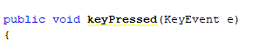
- Defines the small ball start button (press enter to start)

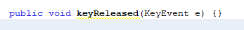
- Receives the event listner interface

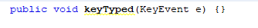
- Calls keyEvent when typing the spacebar

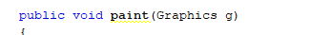
- Fill the brick color

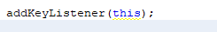
- Defines a keyboard listener

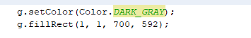
- For setting background

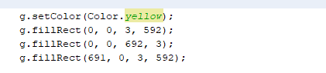
- For border setting

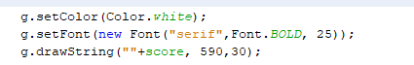
- For score setting

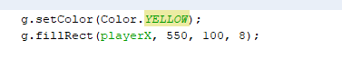
- For paddle setting

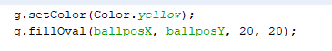
- For ball setting

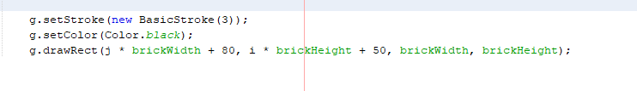
- This is just to show separate brick, game can still run without it

- Screenshots
Add screenshots of your project with proper figure captions

